Identification de l’incident :

|  |  |  |  |
| --- | --- | --- | --- |
| **De :** | Agnes MAZAS |  |  |
| **Date** | 21/01/2020 | | |
| **Classification** | •MAM : Generated Audit | | |
| **Reproductible : Yes** | | | |
| **Version IE** : IE 11.0.9600.18860CO | | | |
| **Version client 3D :** (Connexion au client 3D : touche shift+Ctrl+v) : VDC5.6.4 . MAM.01.19.2020 | | | |

Steps to reproduce :

# Problem

A device in a Generated Audit is needed to be validated in another Generated Audit because of the use of the same rack

# Steps to reproduce

We have two Generated Audit [WO AMA Move 27]_[158543] and [WO Install Srv BL 81]_[158477].

Both are concerning servers in the same rack V3-G-07.

## Open generated audit A : [WO Install Srv BL 81]_[158477]

We cannot see blade server Srv_BL_UCS 5108 A - Slot 2_Ag

## Go in Rackmount Assets tab and validate server Srv_AMA_Install_17

## Go to Audit list

[WO Install Srv BL 81]_[158477] is still in the list

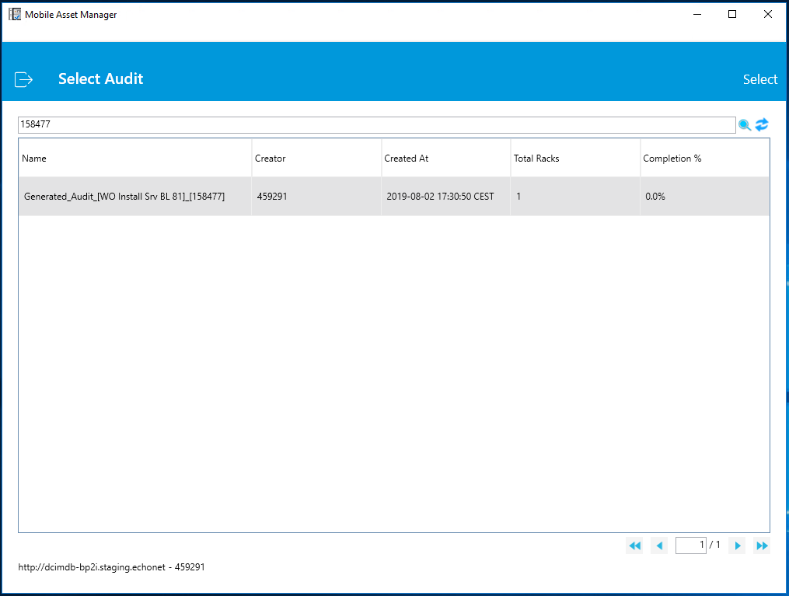

[WO Install Srv BL 81]_[158477] is not completed

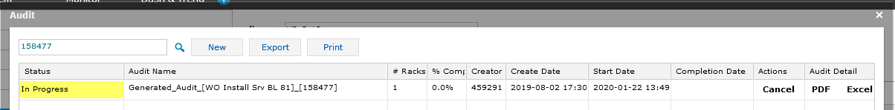

## Go back In rackmount assets tab

Server Srv_AMA_Move_2 is in the list. It belongs in a Generated_Audit B : [WO AMA Move 27]_[158543] which is different from [WO Install Srv BL 81]_[158477].

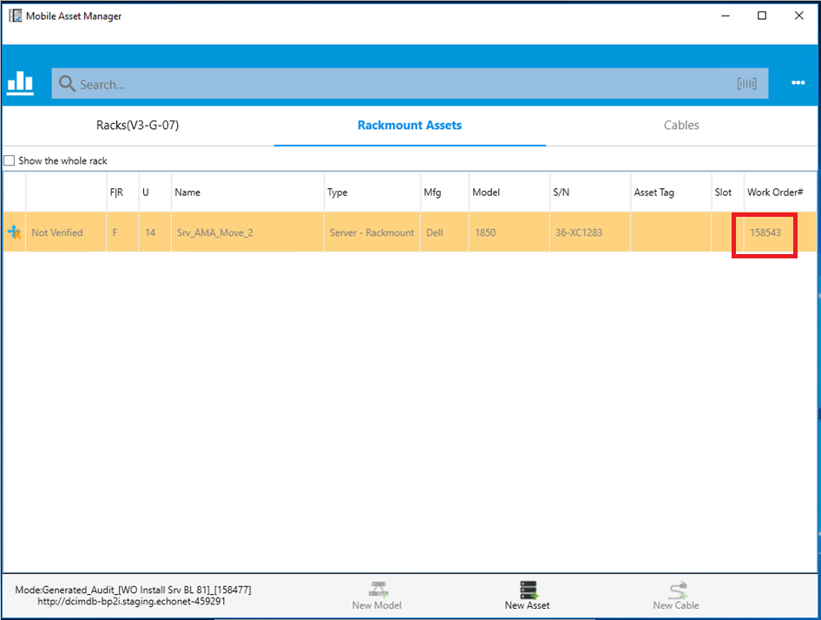

It is impossible to validate [WO Install Srv BL 81]_[158477] without validating [WO AMA Move 27]_[158543].